Spark

Basics of Big Data

BIG DATA
Big Data is basically huge amounts of data that are so large, fast, or complex that traditional databases and tools can't handle them efficiently. It's not just about the size - it's also about how quickly the data is coming in, the variety of data types, and how useful it is.
Key Characteristics (The 5 Vs):
- Volume → Size of data (huge amounts).
- Velocity → Speed at which data is generated and processed.
- Variety → Different types of data (structured, unstructured, semi-structured).
- Veracity and Value → Reliability and usefulness of data.
Examples:
- Social media posts, sensor data, transaction logs, streaming video/audio.
Challenges:
- Storage and management.
- Processing speed.
- Data quality and security.

Before Big Data
Data flow was simple: web applications connected directly to databases, handling limited volume, velocity, and variety of data. Big Data is defined by three main features: Volume, Velocity, and Variety, which traditional databases struggle to handle efficiently.

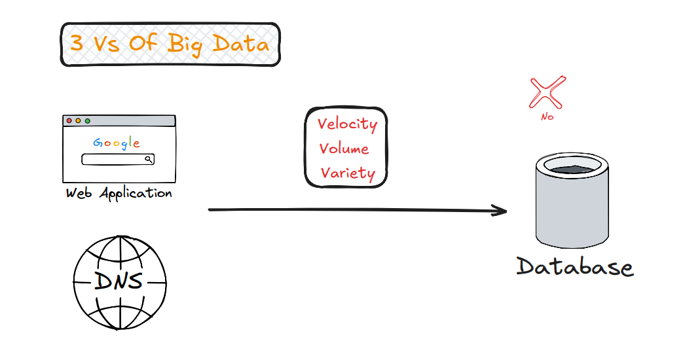

Monolithic (Vertical Scaling)
In a monolithic architecture, the web application connects to a single server. Scaling is done vertically by adding more resources like RAM, processor, and ROM to the same server.
Key Characteristics:
• Single server handles all tasks
• Vertical scaling → increase hardware resources
• If the server fails, the whole system goes down
Examples: • Traditional web applications with one central server
Challenges: • Limited scalability • High dependency on one server • Risk of complete system failure
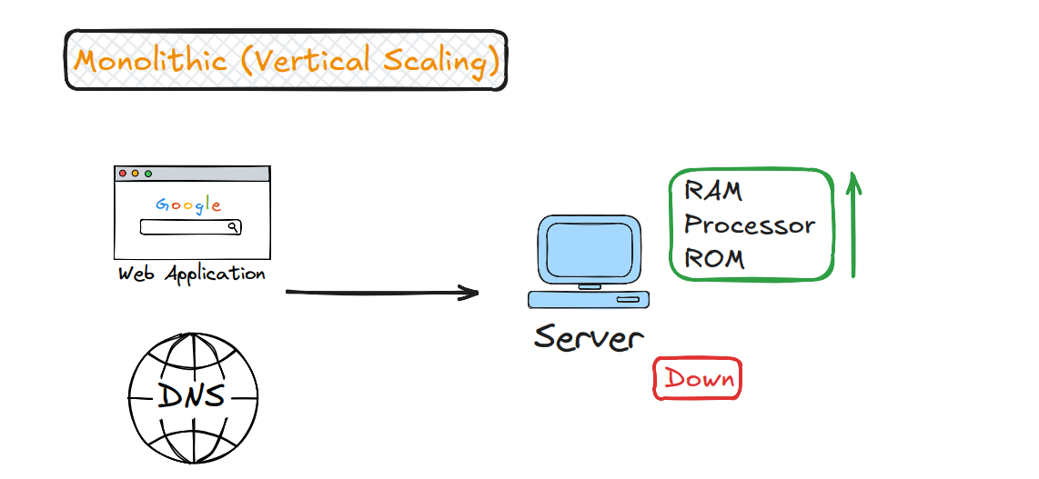

Distributed (Horizontal Scaling)
In distributed architecture, the web application connects through DNS to multiple servers. Scaling is done horizontally by adding more servers to share the load, improving performance and reliability.
Key Characteristics: • Multiple servers handle tasks together • Horizontal scaling → add more servers • System continues working even if one server fails
Examples: • Cloud computing platforms • Large-scale web applications
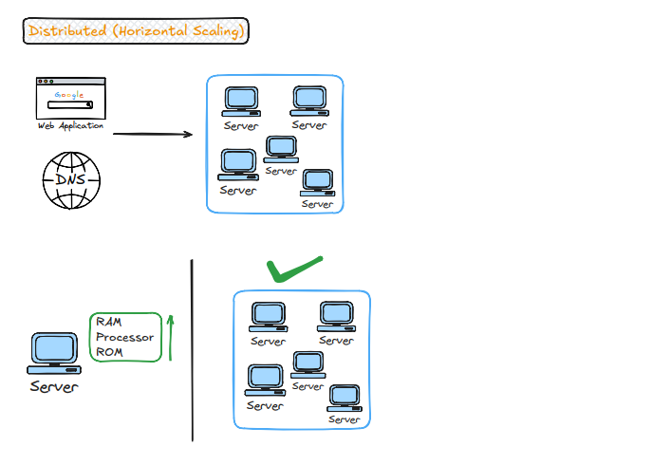
Challenges: • Complex management of multiple servers • Data consistency across servers • Higher networking overhead
Here’s an enriched and clear note set on Hadoop and MapReduce, now including the performance and practical limitations you mentioned:

Hadoop
Hadoop is an open-source framework for storing and processing massive datasets across clusters of computers. It has two main components:
- HDFS (Hadoop Distributed File System): Splits large files into blocks (default 128 MB), distributes them across servers, and replicates for reliability.
- MapReduce: A programming model that processes data in parallel using Map → Shuffle → Reduce steps, with computation moving to where the data is stored.

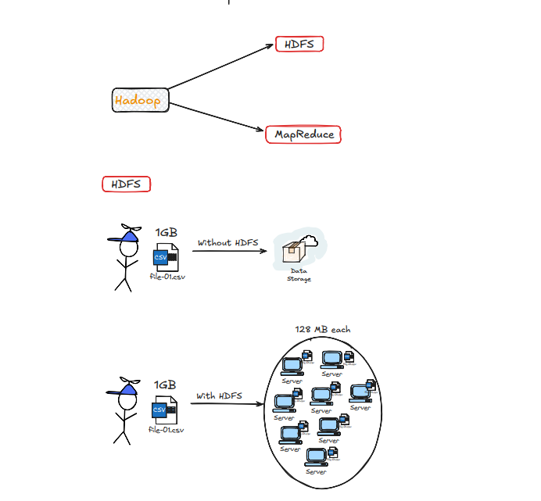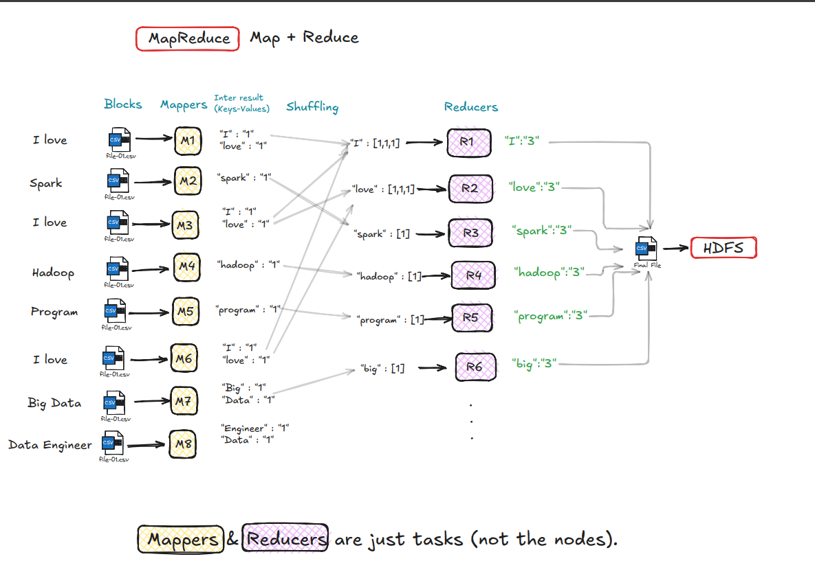
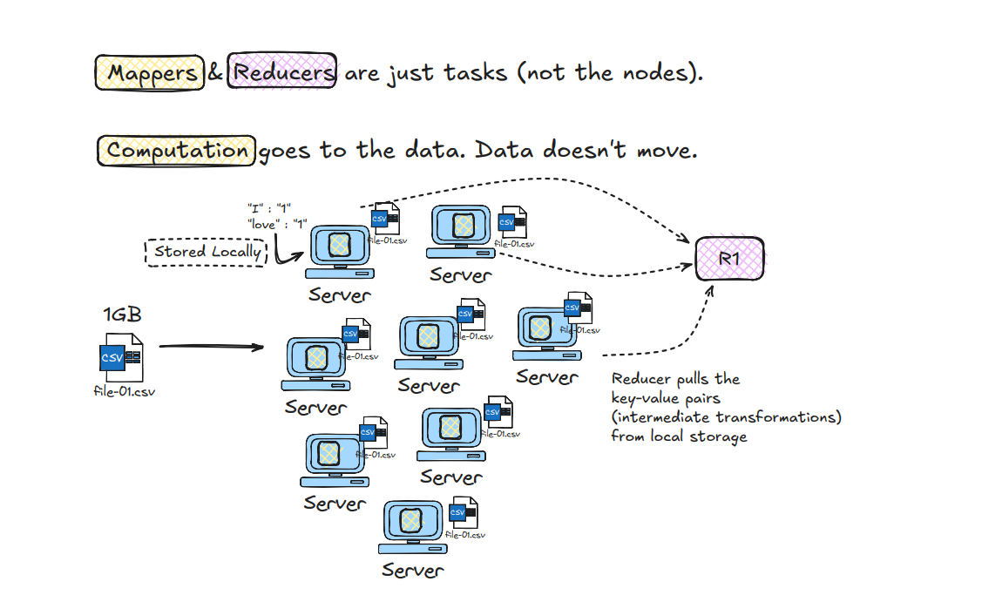
Limitations & Issues:
- Performance Bottlenecks
  - High latency due to disk I/O between map and reduce phases.
  - Example: In log analysis, intermediate data is written to disk before shuffle/reduce, slowing large-scale jobs.
  - Scenario: Grouping sales data by region → Map emits (“East”,100), (“West”,200)… Shuffle writes to disk, Reduce sums totals. Delay occurs because all intermediate data is disk-based, not in memory.
- Development Complexity
  - Writing MapReduce jobs requires verbose boilerplate code.
  - Developers must manually handle parsing, mapping, reducing, and error handling even for simple tasks.
- Lack of Real-Time Processing
  - Only supports batch jobs.
  - Cannot be used for real-time tasks like fraud detection in financial transactions.
- Inflexible Execution Model
  - Strict Map → Shuffle → Reduce workflow.
  - Iterative algorithms (e.g., k-means clustering) are inefficient due to repeated disk writes.
- No Interactivity or Monitoring
  - No interactive mode for inspecting intermediate results.
  - Debugging requires rerunning entire batch jobs.
Simple Example (Word Count):
- Map: (“I”,1), (“love”,1), (“Hadoop”,1)
- Shuffle: Groups by key → “I”:[1,1], “love”:[1,1]
- Reduce: Aggregates → “I”:2, “love”:2, “Hadoop”:1
- Output stored in HDFS
To overcome those limitations, Spark came into picture instead of MapReduce:

Apache Spark
Apache Spark is a unified distributed computing engine that processes Big Data in parallel. It is considered an alternative to Hadoop MapReduce, but still works with HDFS for storage.
Why Spark is Unified Spark uses a single engine to handle multiple workloads: • Batch processing • Streaming (real-time analytics) • Machine learning (MLlib) • Big data analytics
👉 Developers don’t need separate tools — Spark supports all under one framework.
Strengths:
- In-memory computation → faster than Hadoop MapReduce (less disk I/O).
- Supports real-time and interactive queries.
- Rich APIs in Python, Java, Scala, and R.
- Scales easily across clusters.
Limitations:
- Requires more memory; can be resource-intensive.
- Cluster setup and tuning can be complex.

Spark Architecture
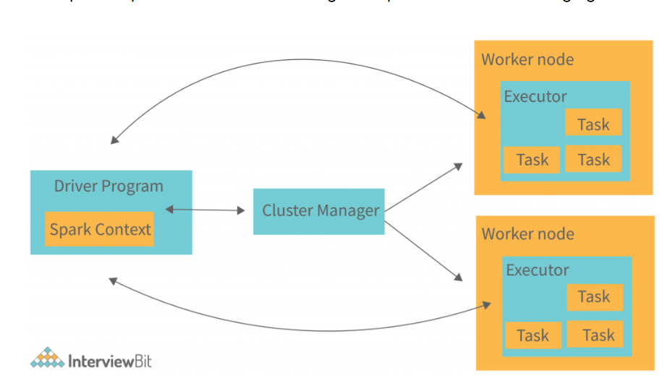
Apache Spark Architecture
- Initialization: • User submits code with worker/driver configuration. • Cluster Manager elects a Driver and initiates the Application Master. • Driver requests resources; Cluster Manager allocates them.
- Driver Program: • Runs the main application and creates SparkContext (gateway to the cluster). • Contains key components: DAG Scheduler, Task Scheduler, Backend Scheduler, Block Manager. • Translates user code into jobs, stages, and tasks.
- Cluster Manager: • Allocates resources and manages job execution. • Works with the Driver to distribute tasks across worker nodes.
- Worker Nodes & Executors: • Worker nodes run Executors, which execute tasks and cache results. • Executors register with the Driver at startup and remain active for the Spark Application’s lifetime. • Tasks are parallelized across executors; partitions of RDDs are assigned to them.
- Execution Flow:
  - Driver submits job → SparkContext.
  - Cluster Manager assigns resources.
  - Job split into stages → tasks.
  - Executors on worker nodes run tasks in parallel.
  - Results returned to Driver, optionally cached.
- Key Features: • In-memory computation → faster than Hadoop MapReduce. • Dynamic allocation of executors. • Supports multiple workloads (batch, streaming, ML, graph).
👉 In short: Driver (logic + scheduling) → Cluster Manager (resources) → Worker Nodes (executors + tasks), all working together for fast, parallel Big Data processing.

Modes of Execution in Spark
- Cluster Mode: Driver runs inside the cluster on a worker node. Most common for production.
- Client Mode: Driver runs on the client machine (gateway/edge node) that submits the job.
- Local Mode: Entire Spark application runs on a single machine using threads. Best for testing or development, not for production.
👉 In short:
- Cluster Mode = driver in cluster (production)
- Client Mode = driver on client machine
- Local Mode = single machine (testing only)

Spark Context vs Spark Session:
Here’s a short, exam-friendly note for the content you shared:
Spark Contexts vs Spark Session
- Spark Contexts (before Spark 2.0):
  - The SparkContext is the main entry point to a Spark application. It runs on the driver node and connects the application to the Spark cluster, enabling RDD operations and resource management.
  - Separate contexts:
    - SparkContext → Core RDD operations
    - SQLContext → SQL queries
    - HiveContext → Hive support
- Spark Session (from Spark 2.0):
  - Unified entry point for all Spark functionalities.
  - Combines SparkContext, SQLContext, HiveContext.
  - Simplifies usage → one object (SparkSession) for everything.
Example:
python
from pyspark.sql import SparkSession
spark = SparkSession.builder.appName("Example").getOrCreate()
Key Point: Spark Session = single gateway for all Spark features.

Databricks Overview:
Databricks is a cloud-based Data and AI platform built on “lakehouse” architecture combining the strengths of data warehouse and data lake. For a given cloud environment, the databricks data intelligence platform integrates with cloud storage,security, manages and deploys cloud infrastructure.
Important points:
By default wide transformation created 200 partitions. Then AQEShuffled coalesce the partitions.

